Automated PPE detection for workplace safety monitoring

A feasibility study comparing YOLOv8n and RT-DETR-l
Student name: Isuru Peiris

Summary

This study checks if object detection can help check personal protective equipment (PPE) at a distribution centre in Palmerston North. The author used 177 frames from the same video source as a public Roboflow "Electric Safety" dataset and labeled them from scratch using Label Studio. Unlike a pre-labeled dataset, these bounding boxes for training and testing were made completely by me.

This study compared YOLOv8n with RT-DETR-l on a separate test set of 28 images. RT-DETR-l was better than YOLOv8n on all test scores and this is a smaller and fast model. RT-DETR-l is a much larger model that takes about 10 times more parameters than RT-DETR-l and has much slower processing time.
Overall, this prototype shows that using this technology for a small, three-class PPE task is possible when the video looks like the training data. Still, it is not ready for real use yet because the dataset is small and only from one place, and the models still struggle to get high precision and recall for gloves.

Introduction
A supervisor walks around the loading bay a few times during each shift using a paper checklist. This method is inconsistent, does not leave a proper record, and misses things that happen between the walk-throughs. The main stakeholders are management, who need clear evidence before they invest money; safety supervisors; and workers, because their privacy is affected.

Object detection is needed instead of image classification. This is because one picture can have many workers and PPE items at the same time. Classification can only tell you that a helmet is somewhere in the image, but detection can find and count every single item. Because of this, the prototype uses an electrical-safety PPE dataset as a substitute for the real loading-bay situation.

Related work
There are two main types of object detectors. Two-stage detectors like Faster R-CNN (Ren et al., 2015) first suggest regions and then classify them. They are accurate, but they are usually slower than single-stage models, so they were not chosen for continuous monitoring. On the other hand, YOLO (Redmon et al., 2016) predicts boxes and classes in just one step. Newer versions like YOLOv8 and YOLO11 use an anchor-free, separated head and non-maximum suppression (NMS) to delete duplicate boxes (Terven et al., 2023). Because the Ultralytics version (Jocher et al., 2023) does not have a peer-reviewed paper, claims about its structure depend on Terven et al.
Another model, DETR (Carion et al., 2020), treats object detection as set prediction using a transformer, which removes the need for NMS. However, it trains very slowly and has trouble finding small objects. RT-DETR (Zhao et al., 2024) improves on this by adding a hybrid encoder and query selection. It reports better speed and accuracy than YOLO on the COCO dataset using TensorRT on a T4 GPU.
However, COCO-scale data and TensorRT are different from my own setup, which has only 123 training images, uses PyTorch, and does not use TensorRT export. Because of this, their ranking might not be the exact same, although the general trend that RT-DETR trades processing speed for better accuracy compared to YOLO matches what I found in Section 5. Furthermore, Yosinski et al. (2014) point out that early model layers learn general features that can be easily transferred, which supports starting with fine-tuning from COCO weights (Lin et al., 2014). Finally, Padilla et al. (2021) show that average precision (AP) depends on the IoU threshold, which is why I report both mAP@0.5 and mAP@0.5:0.95.

Dataset and annotation
The video frames come from the same public Roboflow "Electric Safety" dataset used before, but the original labels were completely thrown away. Instead, all the bounding boxes in this study were made by the author using Label Studio, which is an open-source tool, following a normal labeling workflow. This fixes the problem with the source of the labels from the earlier draft because the boxes used here are done by the author and not by someone else.
Three classes were labeled: cloth, glove, and helmet. These match the three PPE types needed for the loading bay. All 177 images were labeled and put together first, and the train, validation, and test splits (Table 1b) were carved out from this single pool later, rather than collecting a separate test batch at the beginning.
Table 1a. Full annotated dataset (my own annotations, 177 images)
Class | Instances | Images containing class
Cloth | 177 | 176
Glove | 160 | 126
Helmet | 139 | 138
Total instances | 476 | 177 images total

Split Methodology
Random image-level splitting was not used because the 177 images come from only 14 different source video clips (which can be seen from the Roboflow file names), and frames right next to each other in a clip look almost the same. A random split would put very similar frames from the same clip into different groups, which would make the validation and test scores look artificially high. Instead, whole clips were put into a single group to get an approximate 70/15/15 split by image count. At the same time, every group had to include all three classes, with glove being the rarest class so it needed the most care during the split.
Table 1b. Train / validation / test split, by source video clip
Split | Images | Cloth instances | Glove instances | Helmet instances
Train | 123 | 122 | 89 | 92
Validation | 26 | 27 | 30 | 26
Test | 28 | 28 | 41 | 21
Total | 177 | 177 | 160 | 139

Table 1c. Held-out test set - images containing each class (companion to Table 1b's instance counts).
Class | Instances | Images containing class (of 28)
Cloth | 28 | 28
Glove | 41 | 23
Helmet | 21 | 21

Limitations
An important limitation to state is that all three subsets come from the same 14 clips. Because of this, the test set is not an independent sample; it shares the same camera angles, lighting conditions, and actors as the training set. Grouping by clips stops exact frame duplication, but it does not give the same independence as data collected on a different day or location.

Method

Models
The YOLOv8n baseline was chosen because the training set is very small, having only 123 images, and the target loading-bay camera feed needs a fast, lightweight model instead of a big one. It was compared with RT-DETR-l, which is the Task 3 alternative model. Both models started from weights pretrained on COCO (transfer learning) and were fine-tuned end-to-end on the PPE dataset.
Hyperparameters
Both models were set up to run for up to 100 epochs, with an early-stopping patience of 20 epochs. The image size was 640x640, the batch size was 8, and a fixed random seed (42) was used to make sure the results could be repeated. The data augmentation used default Ultralytics settings, such as mosaic, horizontal flipping, and HSV color jitter. Because there are only 123 training images, this augmentation does important work by creating the variation in lighting, distance, and viewpoint that the assignment asks for, since the original video clips do not have much natural variation
Training Behaviour
Both models stopped early because of the patience setting, well before reaching the 100-epoch limit. This shows the patience setting worked properly, rather than the models needing more training time. YOLOv8n reached its best validation mAP@0.5:0.95 score of 0.438 at epoch 42. After that, it trained for another 20 epochs with no improvement and stopped at epoch 62. RT-DETR-l reached its best score of 0.426 at epoch 44 and stopped at epoch 64. This same 20-epoch gap confirms that early stopping worked the exact same way for both models.
For YOLOv8n, the training box loss went down steadily from 1.815 to 1.186. However, the validation box loss was noisy and went up slightly by the final epoch, moving from 1.802 to 1.893. This is a small sign of overfitting, although the very small validation set of 26 images means some of that noise is normal rather than a clear trend. The precision, recall, and mAP curves rise sharply in the first 10 epochs and then stay mostly flat with small ups and downs, which means the model learned as much as it could from a dataset of this size.
Table 2. Training configuration
Setting | YOLOv8n | RT-DETR-l
Parameters | 3,006,233 | 31,989,905
Image size / batch | 640 / 8 | 640 / 8
Epochs run (best epoch) | 62 (best-42) | 64 (best-44)
Training time | 3.1 minutes | 14.3 minutes
GFLOPs | 8.1 | 105.3

Comparison fairness

RT-DETR-l was trained with the same epoch budget and patience as YOLOv8n for a controlled comparison, but transformer detectors often need more training to fully converge than CNN detectors of a similar generation. Here, RT-DETR-l still reached its own best epoch (44) on almost the same schedule as YOLOv8n (42) and clearly outperformed it on the test set so in this instance the equal-budget comparison does not appear to have disadvantaged RT-DETR-l.

Results and evaluation
All figures and numbers below come from loading yolov8n_best.pt and rtdetr_best.pt and evaluating on the 28-image, 90-instance held-out test split. These exactly reproduce the confusion matrix and PR curve images which in my_model_3.zip.
Table 3. Test-set results (28 images, 90 instances).
Model | Precision | Recall | mAP@0.5 | mAP@0.5:0.95 | Params | Latency (ms/img)
YOLOv8n | 0.758 | 0.687 | 0.762 | 0.322 | 3.01M | 126.6
RT-DETR-l | 0.936 | 0.790 | 0.804 | 0.343 | 32.81M | 1249.7

Per-Class Performance
Table 4 breaks down the test-set performance for each individual class (cloth, glove, and helmet).

Table 4. Per-class test-set results.
Class | Model | Precision | Recall | mAP@0.5 | mAP@0.5:0.95
cloth | YOLOv8n | 0.903 | 0.667 | 0.878 | 0.402
cloth | RT-DETR-l | 0.916 | 0.784 | 0.752 | 0.300
glove | YOLOv8n | 0.465 | 0.537 | 0.482 | 0.153
glove | RT-DETR-l | 0.937 | 0.585 | 0.664 | 0.242
helmet | YOLOv8n | 0.906 | 0.857 | 0.928 | 0.412
helmet | RT-DETR-l | 0.956 | 1.000 | 0.995 | 0.487

Visualizations and Error Analysis
Training and validation loss and mAP curves (yolov8n_baseline/results.png, rtdetr_comparison/results.png). For both models, precision, recall, and mAP curves rise sharply in the first 10 epochs and then stay mostly flat with small ups and downs. This is normal behavior for transfer learning on a small dataset, not a sign that the training was cut short.
yolov8n_baseline/results.png
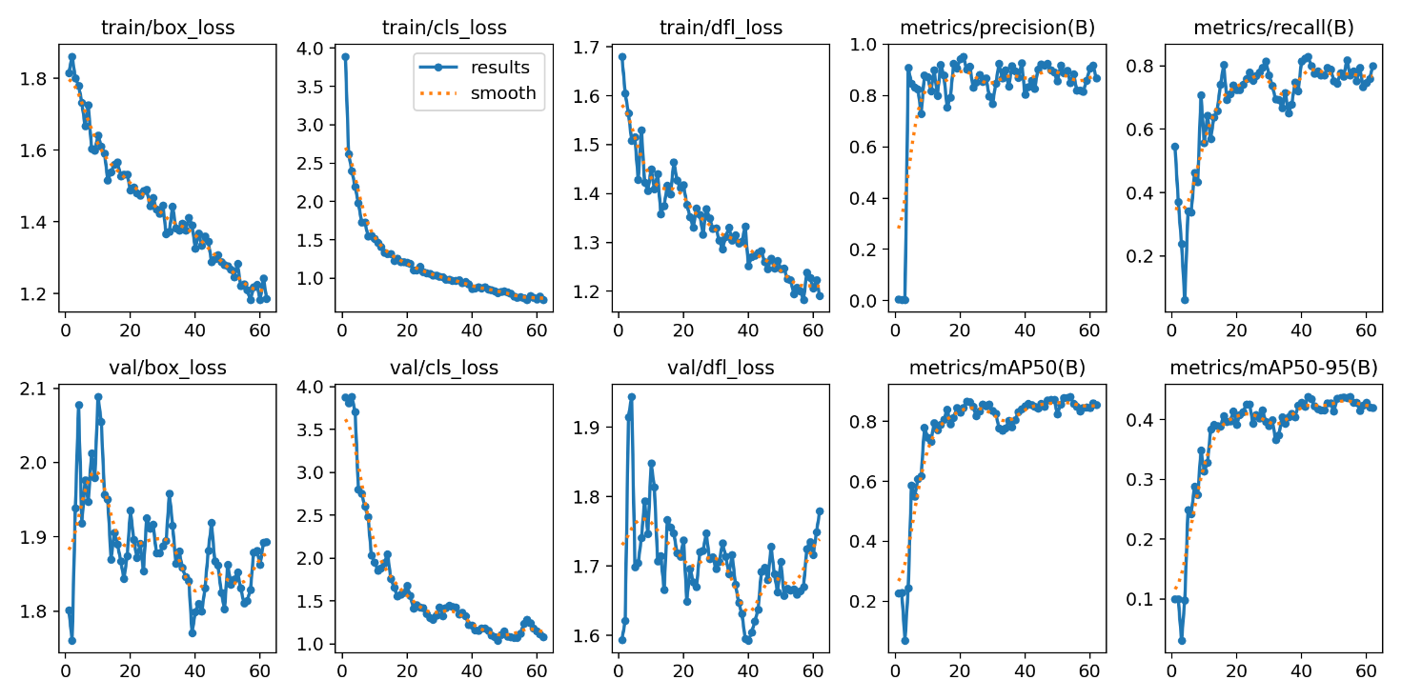
rtdetr_comparison/results.png
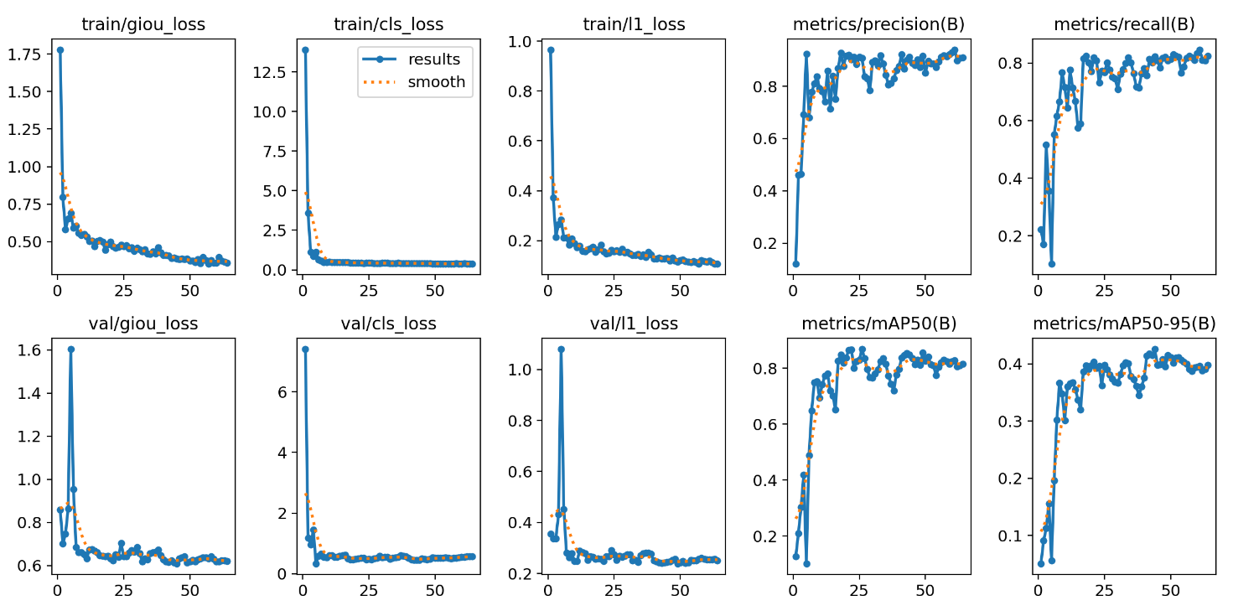
Normalized confusion matrix. For YOLOv8n, the correct-class rates were cloth 0.61, glove 0.46, and helmet 0.86, while the rest were missed and predicted as background. Out of the background false positives, 94% were wrongly labeled as glove, and almost none as cloth or helmet. For RT-DETR-l, the correct-class rates were cloth 0.68, glove 0.56, and helmet 1.00, with background false positives split more evenly (67% cloth and 33% glove). In both models, glove is the class that gets missed the most. For YOLOv8n, glove is also where almost all false alarms happen, meaning it both under-triggers and over-triggers on the same class.

Normalized confusion matrix for YOLOv8n 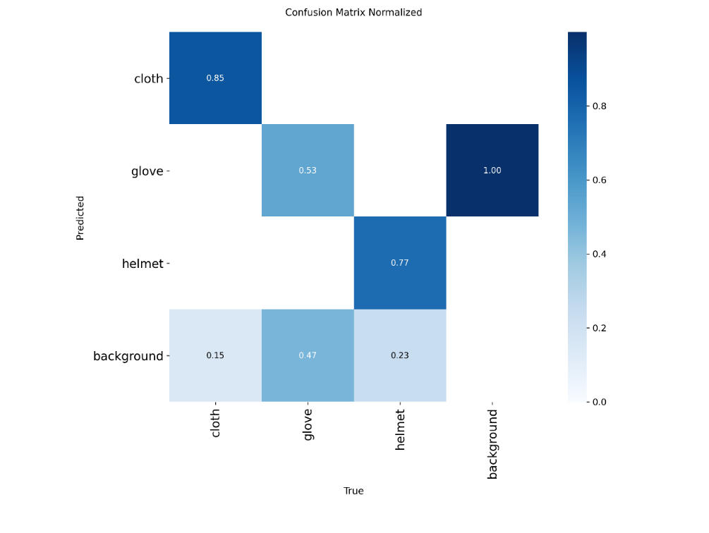
Normalized confusion matrix for RT-DETR-l
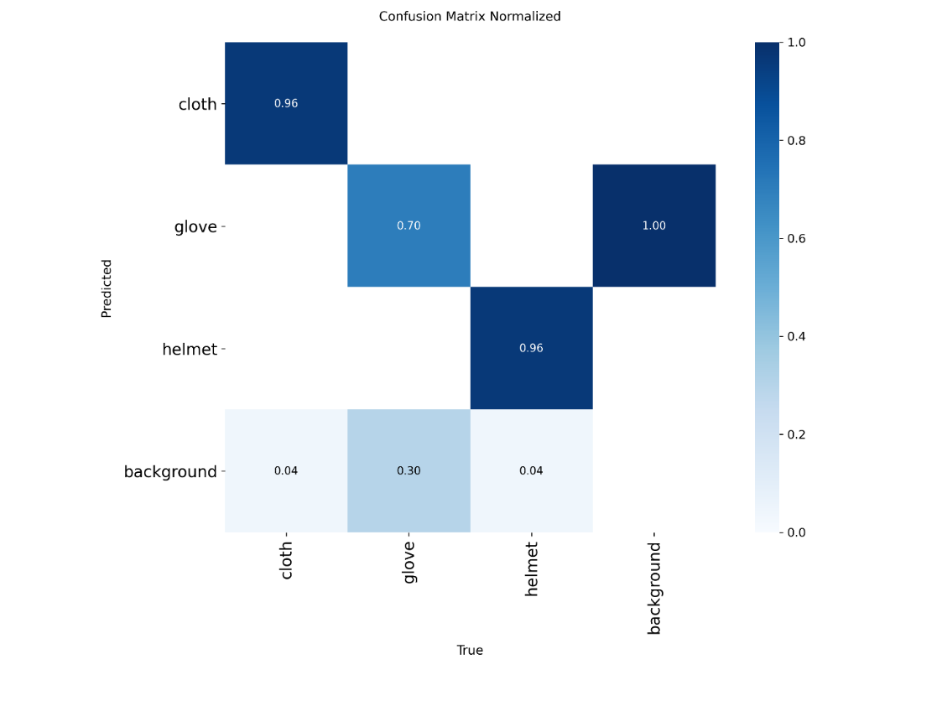
Precision-recall curve.The difference between classes is very clear. Helmet's curve stays near the top-right corner for both models, showing high precision up to high recall. On the other hand, glove's curve drops quickly. For YOLOv8n, precision falls below 0.5 by around 45% recall. RT-DETR-l's glove curve stays better for longer before dropping past roughly 65% recall.
BoxPR_curve.png for YOLOv8n
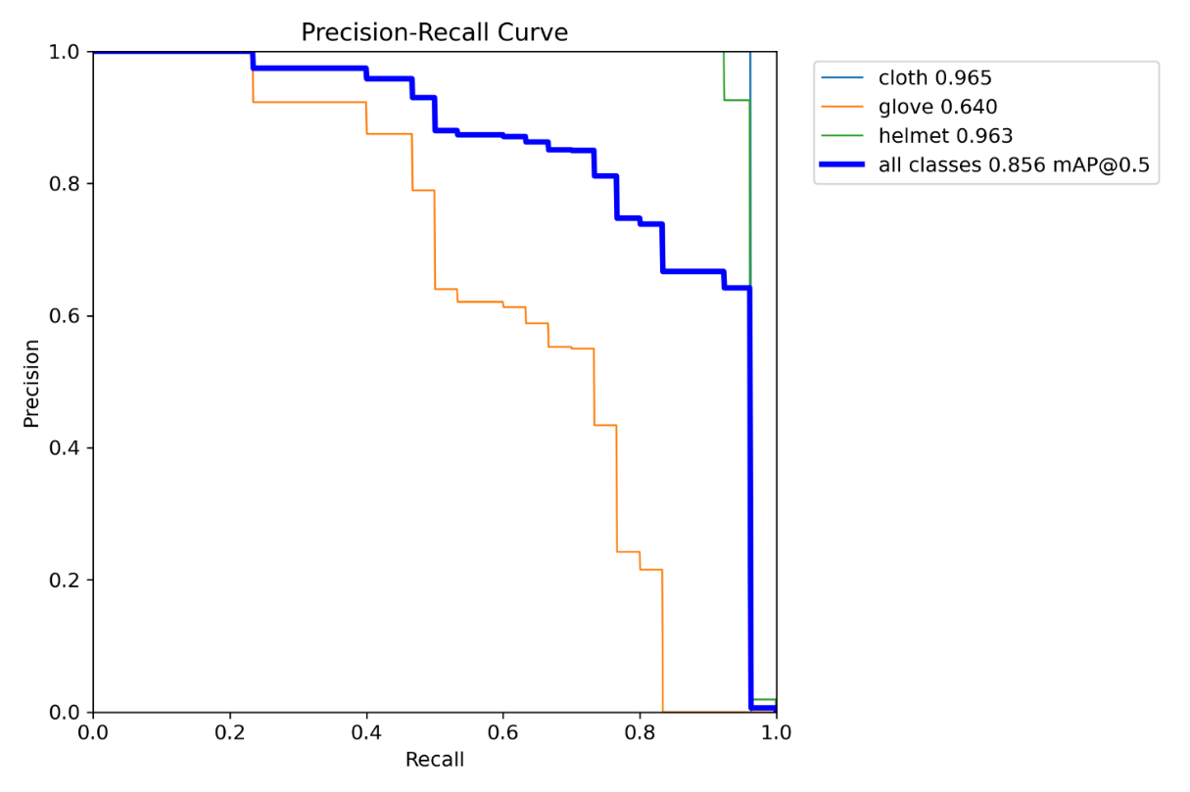

BoxPR_curve.png for RT-DETR-l
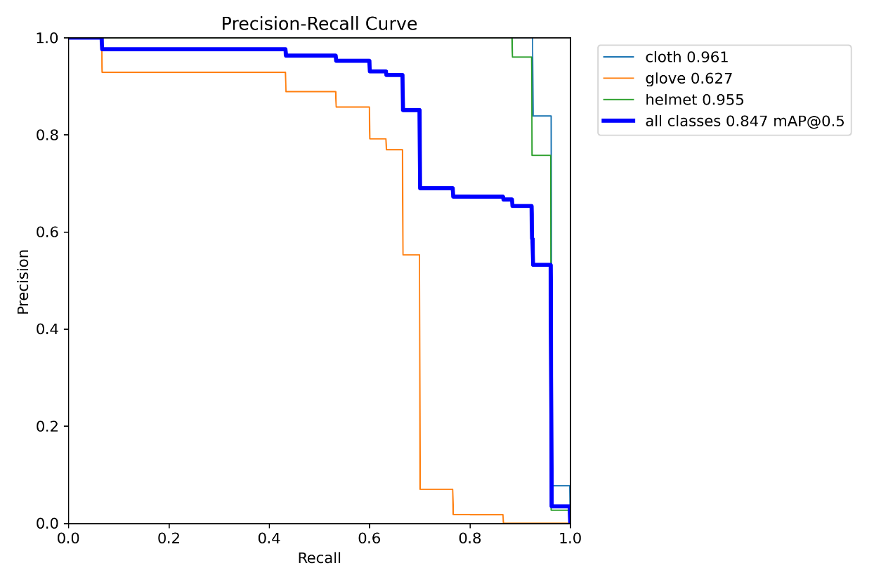

Annotated Failure Examples
- Missed detection - A worker with a glove on both hands was only detected on one hand and the cloth detection missing as well.
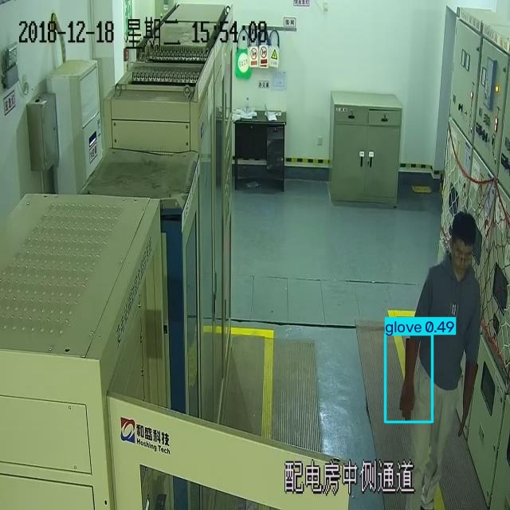

- Missed detection - A worker with a helmet on the hand only detect the cloth not detected the helmet.
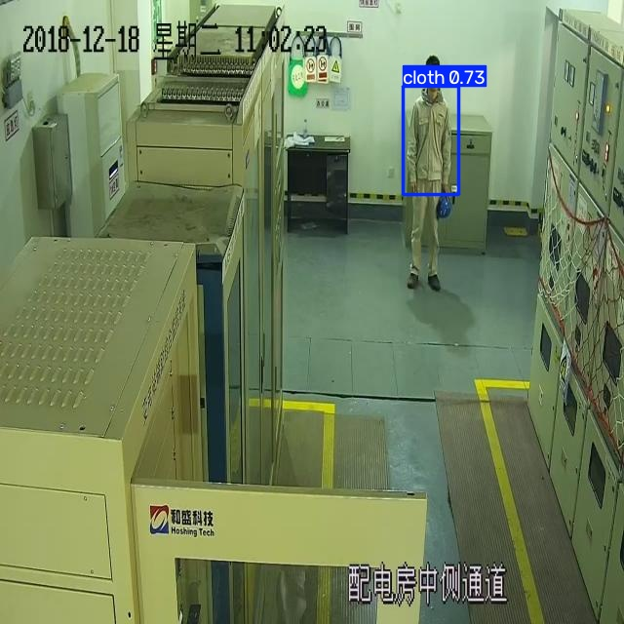
- Missed detection - A worker with all classes but only detected the helmet.
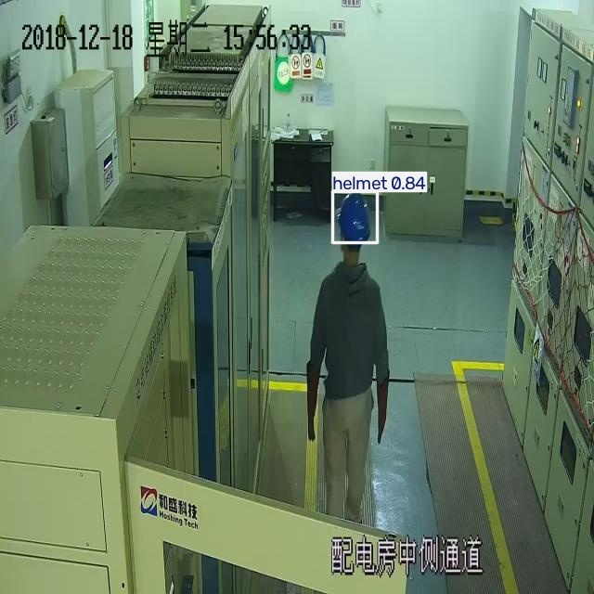

- Duplicate or overlapping detections -2 overlapping "glove" boxes with confidences of are predicted on the exact same gloved hand.
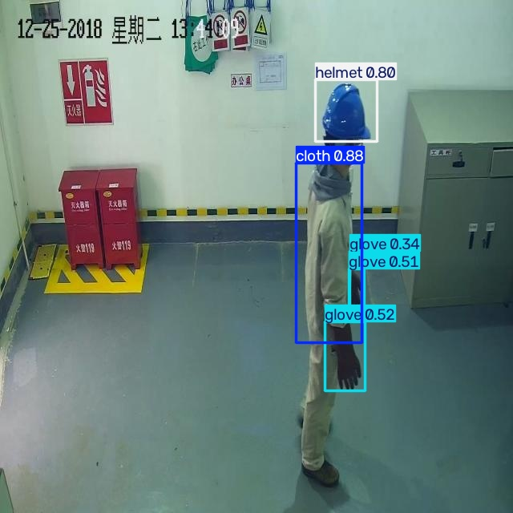

6. Discussion, limitations and recommendation
Recommendation
For a loading-bay setup where the system needs to run live video feeds on small edge devices, YOLOv8n is still the more practical choice even though it has lower accuracy. It is about 10 times smaller and much faster per frame, even if we consider that CPU-versus-GPU tests give different latency numbers. However, this recommendation depends on the situation. RT-DETR-l is much better where it counts the most, such as glove precision and recall (0.937/0.585 compared to 0.465/0.537) and a near-perfect helmet recall of 1.000. If the system can handle slightly slower processing speed is like checking frames in short batches instead of every single frame, or using a server instead of an edge device then RT-DETR-l's lower number of false PPE warnings would be worth the extra computer power for a safety job. This is a draft recommendation that you can change, as it comes from Tables 3 and 4, but you need to make the final trade-off clear.
Limitations
- The dataset is still small, with only 177 images in total, which is at the low end of the assignment guide of 150 to 300 images. Also, it uses a few fixed overseas CCTV scenes instead of a real loading bay in Palmerston North.
- There is no person class, so the system cannot tell which specific worker is missing their PPE.
- The train, validation, and test sets all come from the same 14 source clips. Grouping by clips stops exact duplicate frames from mixing into different sets, but the sets are still not collected independently.
- Gloves are confirmed as the weakest class for both models because they have the lowest AP@0.5 in Table 4. For YOLOv8n, gloves also cause almost all the false alarms shown in Figure 2, which means it has a double failure of missing real gloves and imagining gloves that are not there.
- RT-DETR-l was trained using the same epoch limit as YOLOv8n. Section 4 explains why this did not clearly disadvantage it here, but using the same training rules for both is still a simple approach worth mentioning.
- The reported latency in Table 3 comes from a CPU test environment, not the GPU hardware that a real setup or the original training would use.

Deployment

Running edge inference right next to local IP cameras avoids cloud delays and internet problems. Changes over time, like seasonal lighting or new PPE colors, can be handled by checking low-level detections and retraining the model regularly.

Ethics and New Zealand Context

Workers should be consulted based on the Employment Relations Act 2000, and data collection must be limited to safety reasons under the Privacy Act 2020 by processing frames locally and keeping only zone-level violation records. This system does not replace duties under the Health and Safety at Work Act 2015. A false positive could lead to unfair punishment, while a false negative in a dangerous area gives a false sense of security. Therefore, supervisors must make the final decisions. This is clearly shown in Figure 4's third example, where a real violation involving missing gloves was completely missed by YOLOv8n.

Conclusion
This study created and tested a self-labeled, three-class PPE detection dataset with 177 images from 14 video clips. It compared a YOLOv8n baseline with an RT-DETR-l model using a safe train, validation, and test split based on video clips to avoid data leaking. RT-DETR-l performed better than YOLOv8n on all test scores, especially with glove precision, but it used about 10 times more parameters and was much slower. Both models have the same main weakness: gloves are the hardest class to get right. They are missed often, and for YOLOv8n, they cause most of the false alarms. The system shows that it can work on video that looks like the training data, but it would need a bigger, more varied dataset and better glove detection before it could be trusted in a real workplace.

References
Carion, N., Massa, F., Synnaeve, G., Usunier, N., Kirillov, A., & Zagoruyko, S. (2020). End-to-end object detection with transformers. In Computer Vision – ECCV 2020 (pp. 213–229). Springer.
Jocher, G., Chaurasia, A., & Qiu, J. (2023). Ultralytics YOLOv8 [Computer software]. https://github.com/ultralytics/ultralytics
Lin, T.-Y., Maire, M., Belongie, S., Hays, J., Perona, P., Ramanan, D., Dollár, P., & Zitnick, C. L. (2014). Microsoft COCO: Common objects in context. In Computer Vision – ECCV 2014 (pp. 740–755). Springer.
Padilla, R., Passos, W. L., Dias, T. L. B., Netto, S. L., & da Silva, E. A. B. (2021). A comparative analysis of object detection metrics with a companion open-source toolkit. Electronics, 10(3), Article 279.
Redmon, J., Divvala, S., Girshick, R., & Farhadi, A. (2016). You only look once: Unified, real-time object detection. In Proceedings of the IEEE Conference on Computer Vision and Pattern Recognition (pp. 779–788). IEEE.
Ren, S., He, K., Girshick, R., & Sun, J. (2015). Faster R-CNN: Towards real-time object detection with region proposal networks. Advances in Neural Information Processing Systems, 28.
Terven, J., Córdova-Esparza, D.-M., & Romero-González, J.-A. (2023). A comprehensive review of YOLO architectures in computer vision: From YOLOv1 to YOLOv8 and YOLO-NAS. Machine Learning and Knowledge Extraction, 5(4), 1680–1716.
Yosinski, J., Clune, J., Bengio, Y., & Lipson, H. (2014). How transferable are features in deep neural networks? Advances in Neural Information Processing Systems, 27.
Zhao, Y., Lv, W., Xu, S., Wei, J., Wang, G., Dang, Q., Liu, Y., & Chen, J. (2024). DETRs beat YOLOs on real-time object detection. In Proceedings of the IEEE/CVF Conference on Computer Vision and Pattern Recognition (pp. 16965–16974). IEEE.
Appendices
- Appendix A. Label Studio annotation evidence (project screenshots showing bounding boxes for cloth, glove, and helmet).
.
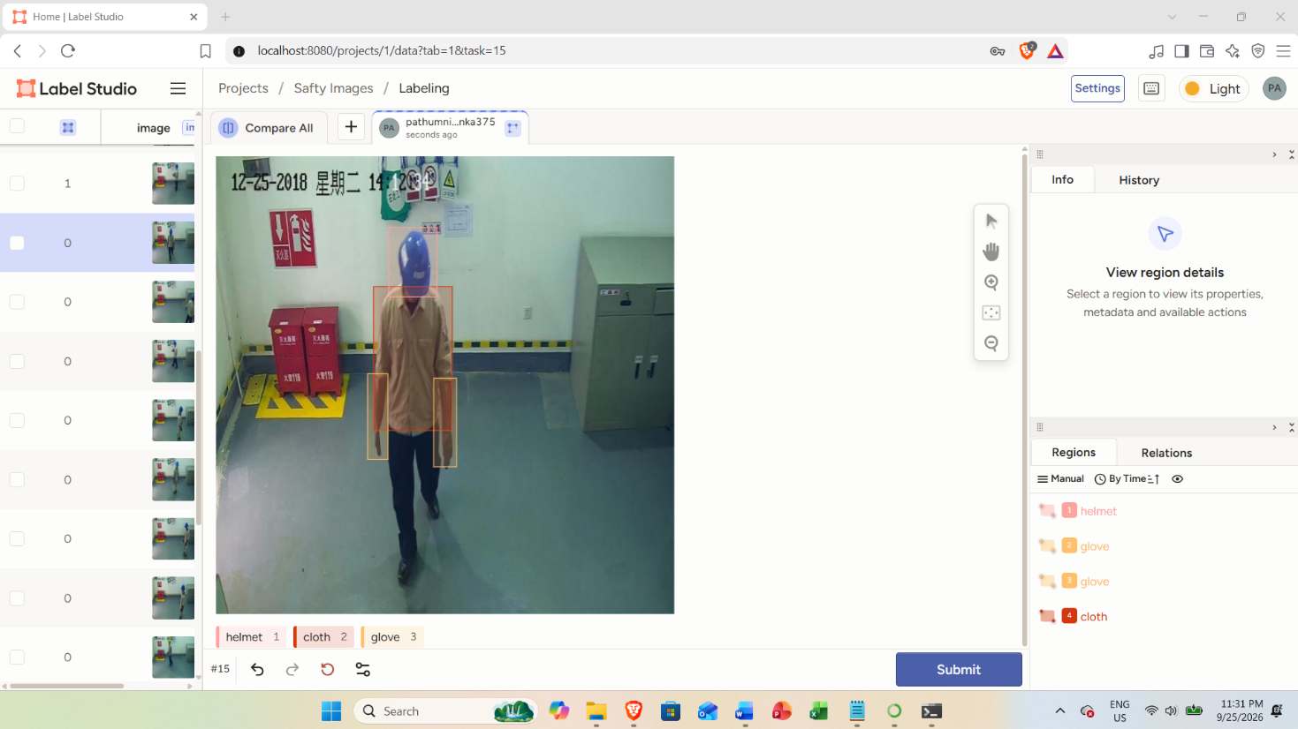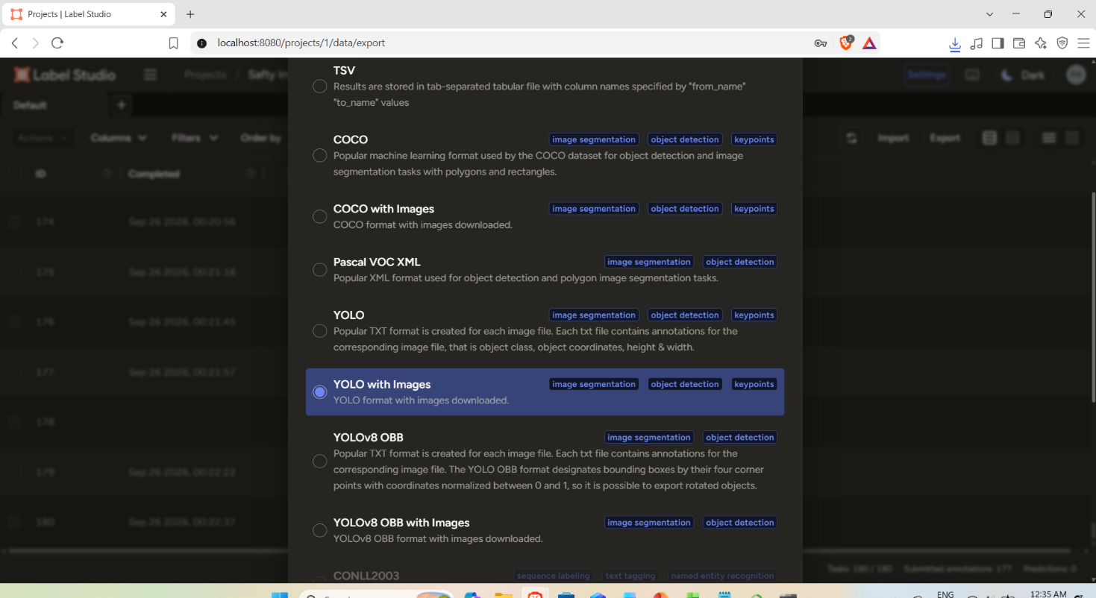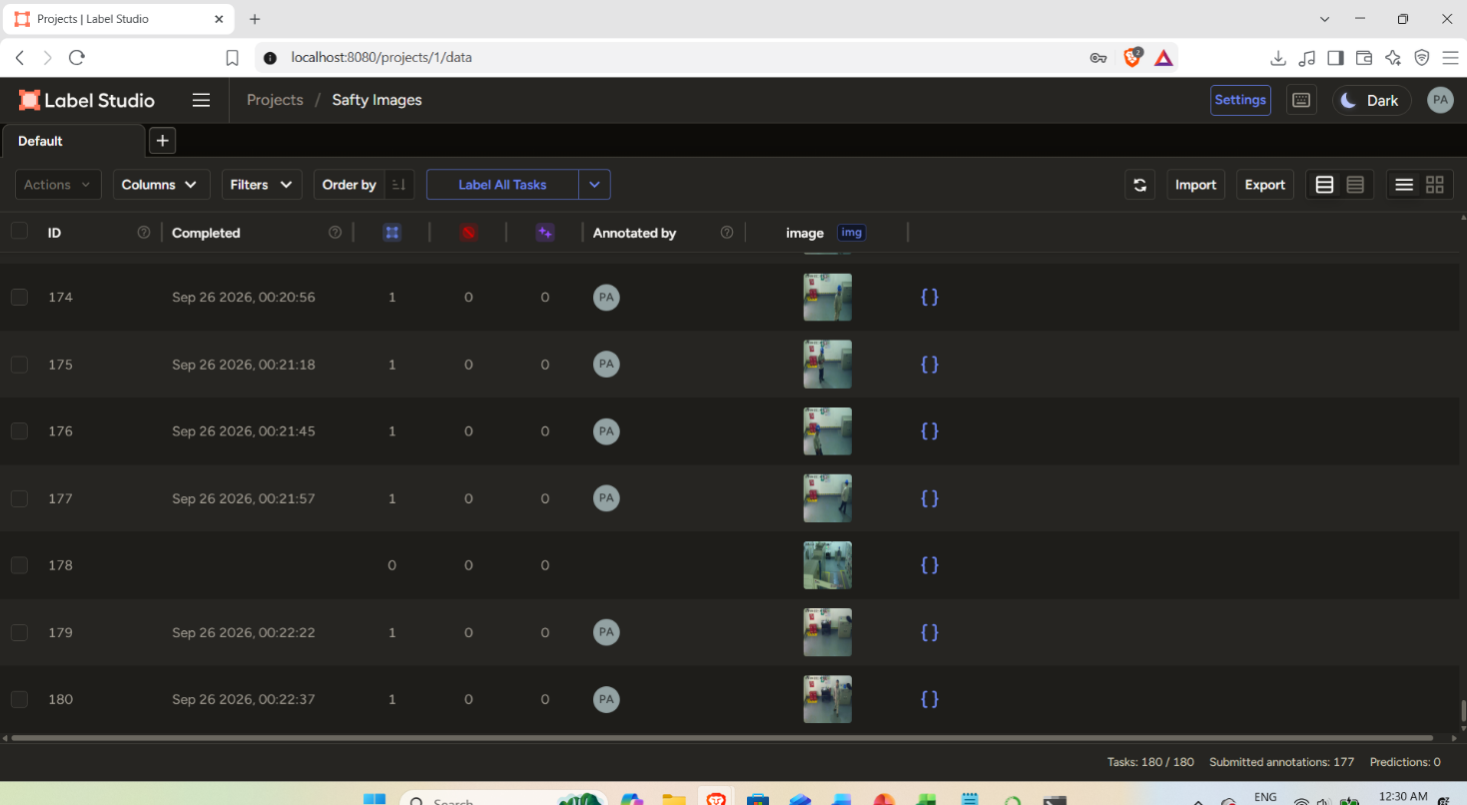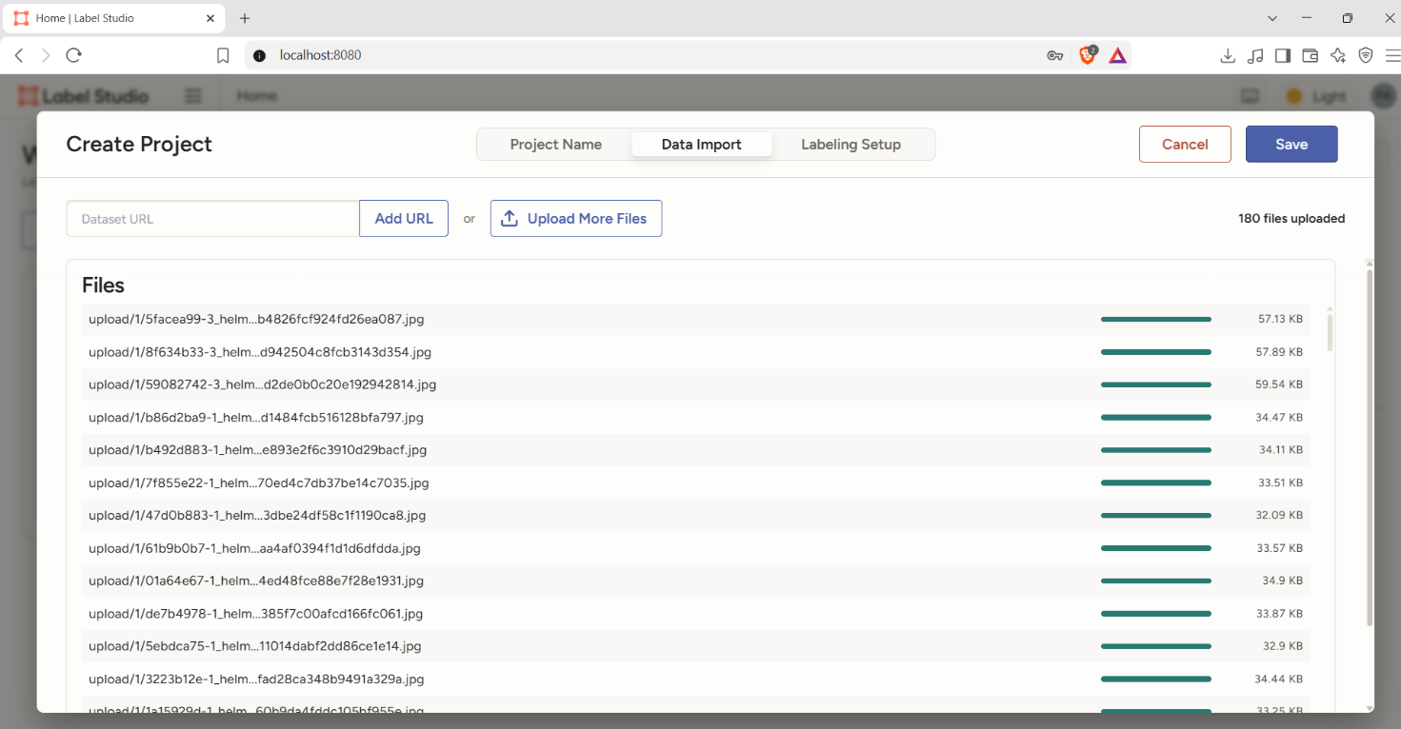
- Appendix B. data.yaml configuration file and dataset description.

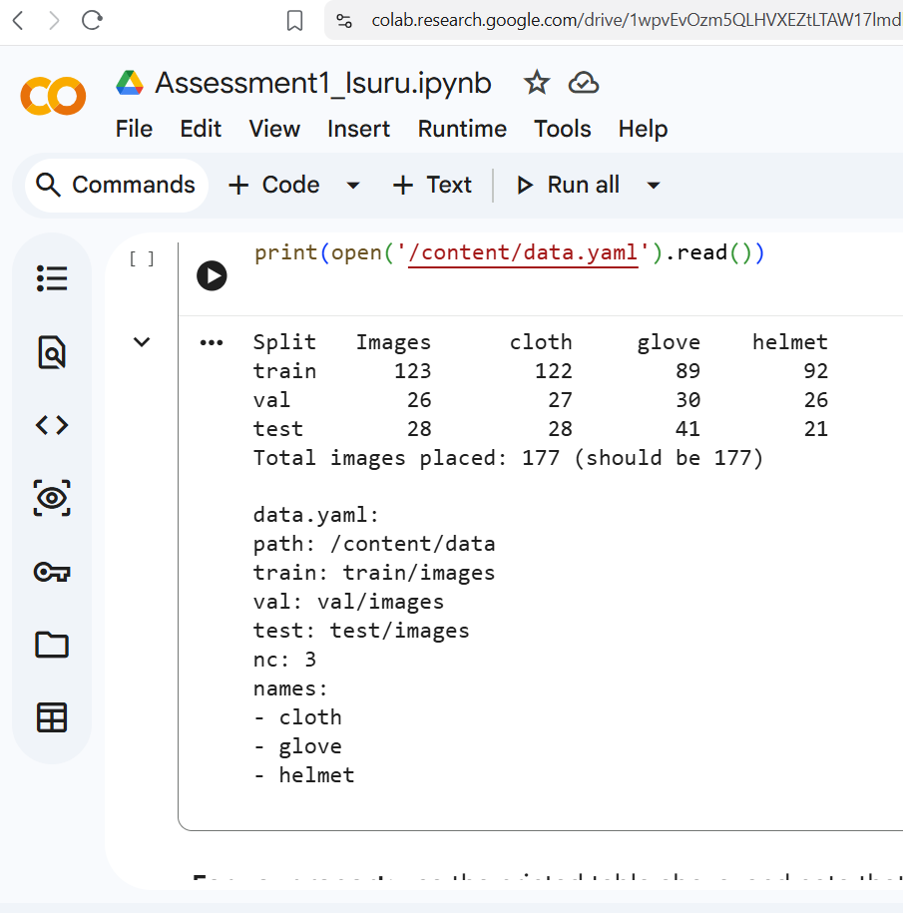
- Appendix C. Full training arguments and library versions (see the args.yaml in each run folder)
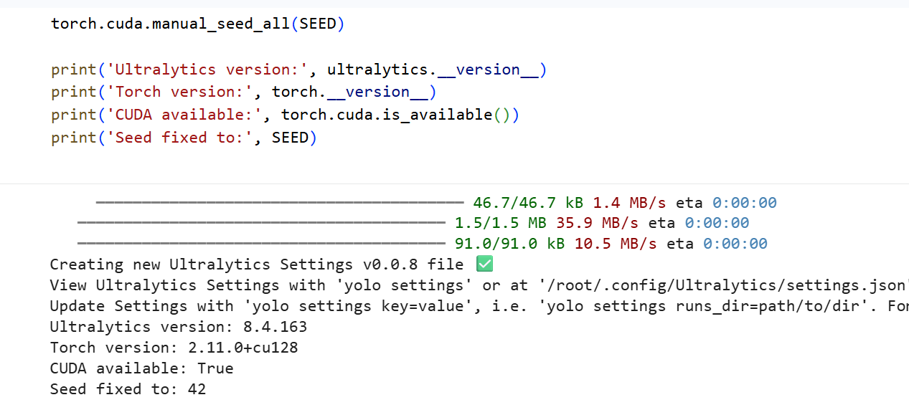

- Appendix D. Additional curves
yolov8n_baseline BoxF1_curve.png, BoxP_curve.png, BoxR_curve.png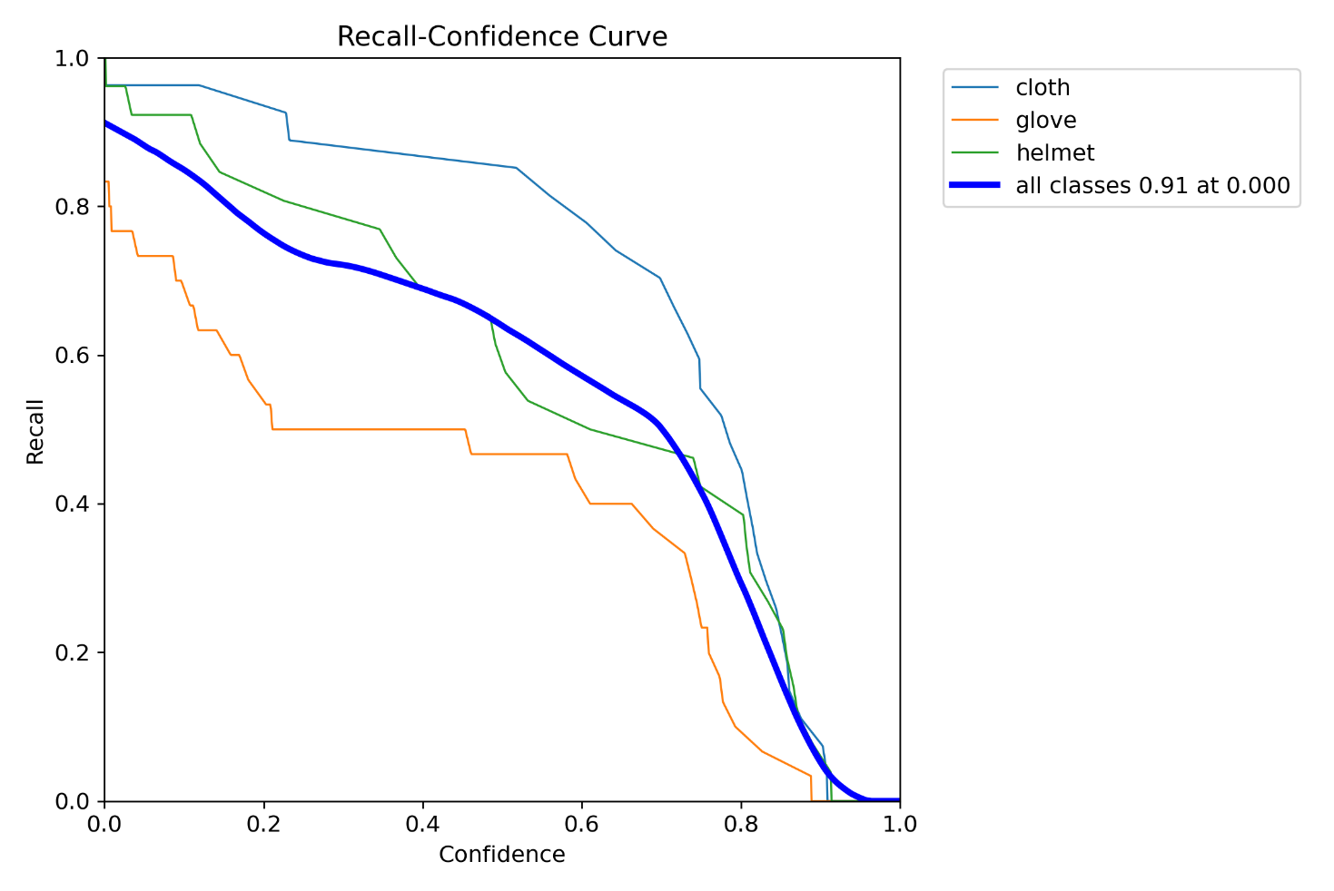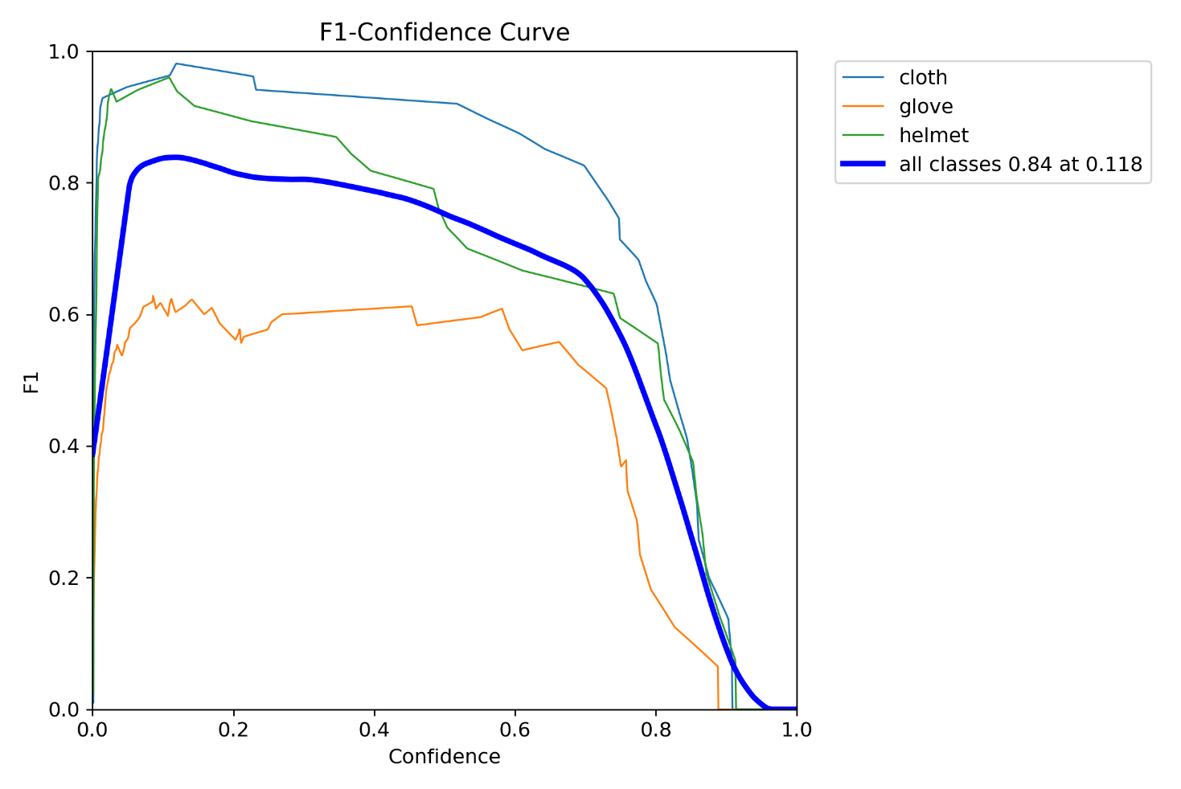

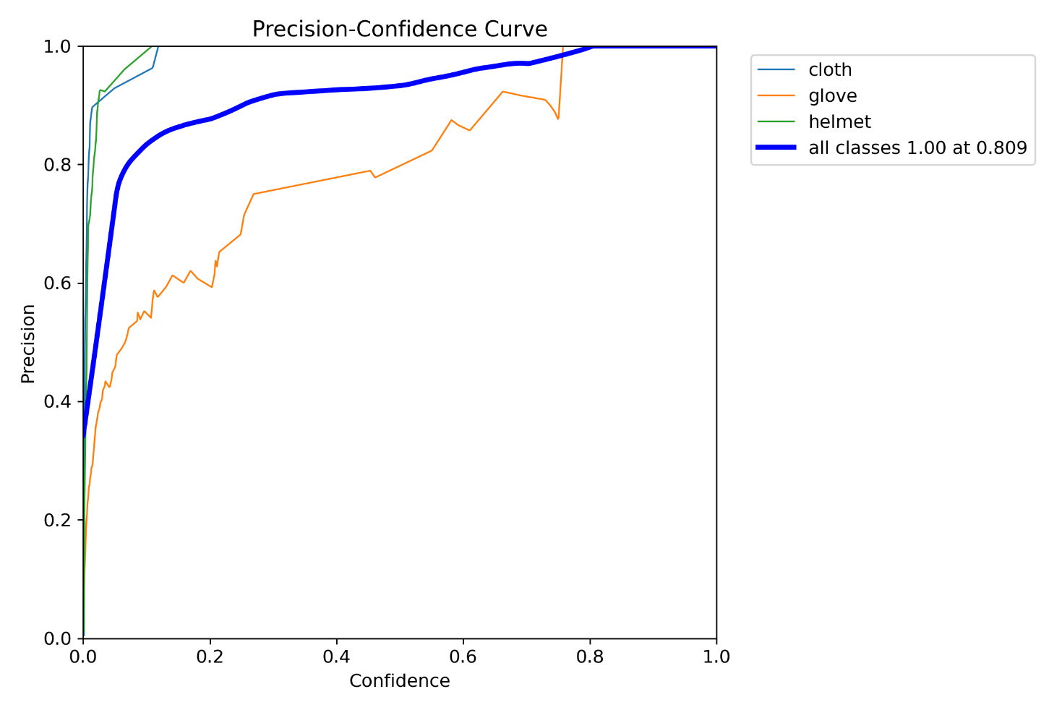
rtdetr_comparison BoxF1_curve.png, BoxP_curve.png, BoxR_curve.png
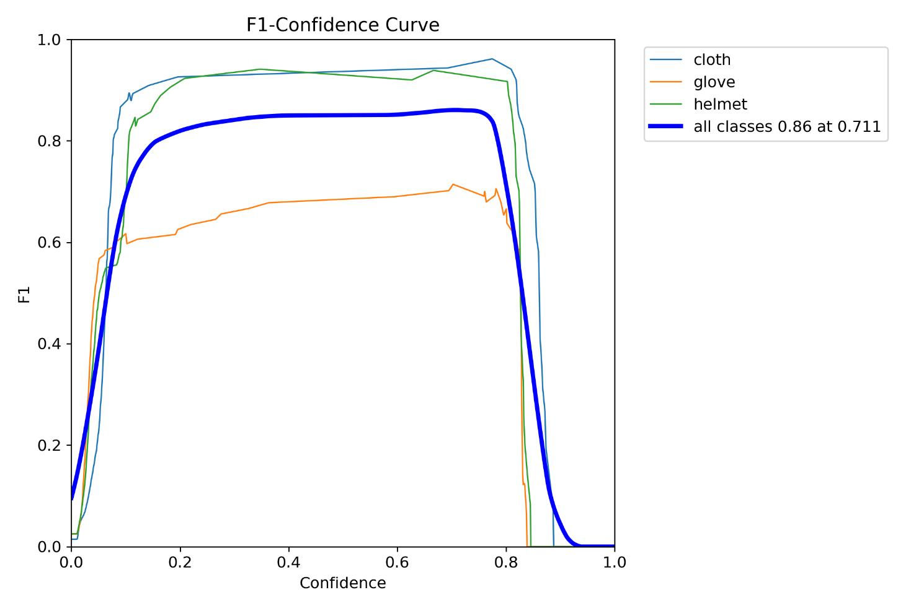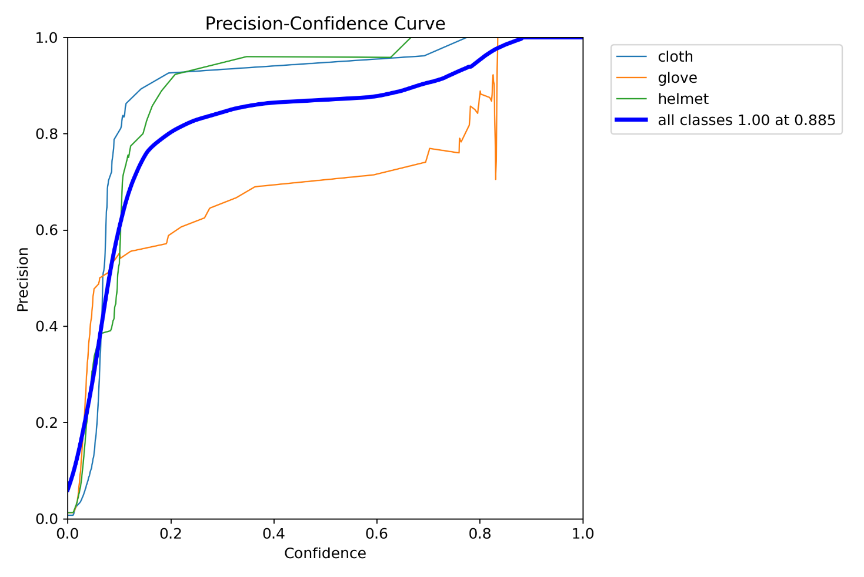

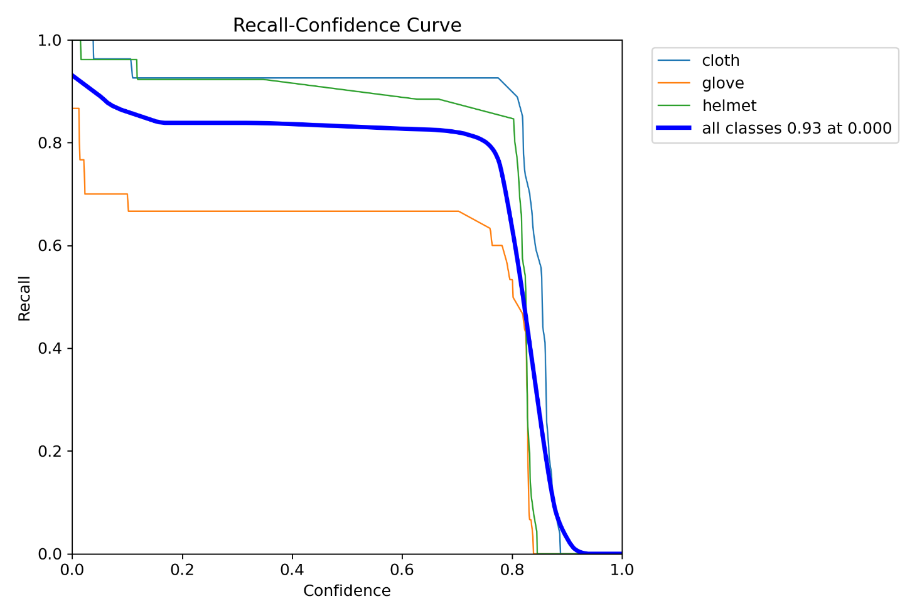

- Appendix E. Domain-shift qualitative check using the unlabeled test images from test.zip to evaluate real-world generalization under unseen camera conditions.
